OFERTA
Va supunem atentiei oferta nostra de produse electrice si electronice pe care le comercializam in prezent.
Daca sunteti interesati de unul sau mai multe din aceste produse, va rugam sa ne contactati la adresa de e-mail office-petra@tuiasi.intreprinderesimulara.ro sau la tel. 0758010691.

Cod.art. | Descriere | Pret in LEI (fara TVA) | Imagine
01 | Desktop HP Compaq dc7900, Intel Core 2 Duo E7500, 1.43GHz, 1066 Mhz, 1GB, 80GB | 440 | 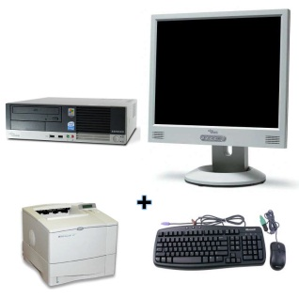
02 | Desktop ET1850 - INTEL DUAL CORE E5700 (3.00 GHz, 2M Cache, 800 MHz FSB) +Monitor 17 Inch + Sistem de operare. | 1200 | 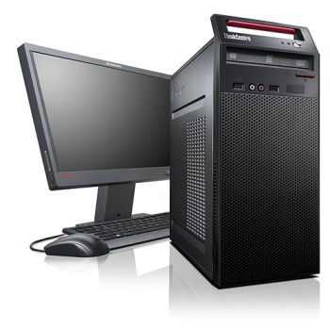
03 | Desktop HP Bundle -Intel Core i3-550 Processor, 2GB PC3-10600 Memory (1x2GB), 320GB 7200RPM SATA, FreeDOS + HP Wide Monitor 20-Inch + Sistem de operare | 1600 | 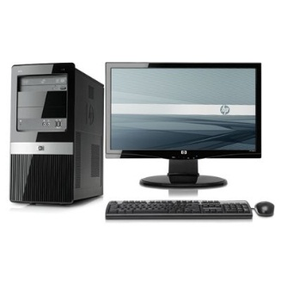
04 | Server Fujitsu Primergy TX100 S1 Monoprocesor, Tower, Redundant+ MS Windows Server 2008 Foundation, 1 x Xeon X3220 2400 MHz 8 MB 1066,2x2GB | 240 | 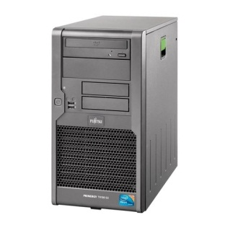
05 | Server HP Micro ServerT07 Athlon II N36L (1.3GHz-2MB/DDR3-800 2C) 1P 1GB (UDIMM) NHP-SATA 4 LFF (1X160GB) | 800 | 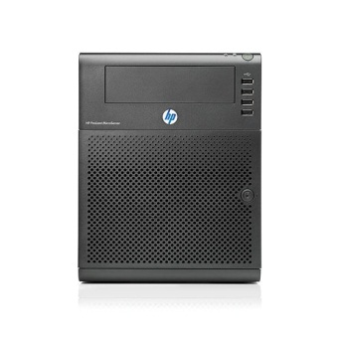
06 | Server HP DL120 G6 - Rack 1U - X3430, 2GB, no HDD | 2000 | 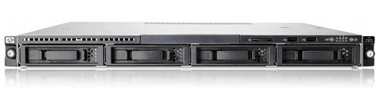
07 | Aparat foto digital Nikon Coolpix L23, 10.1 Mp, Dimensiune ecran: 2.7 inch, Zoom optic: 5x | 160 | 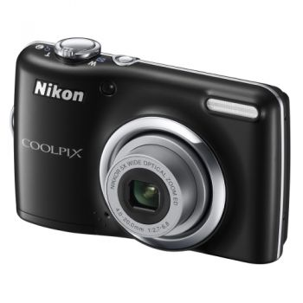
08 | Aparat foto digital Nikon Coolpix S6150, 16 Mp, Dimensiune ecran: 3.0 inch,  Zoom optic: 7x | 400 | 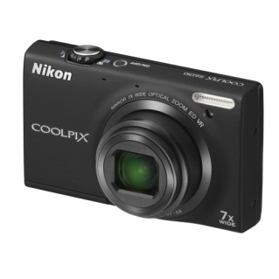
09 | Aparat foto Mirrorless Olympus PEN E-P1 silver 1442 silver Kit, 12.3 Mp, Ecran LCD (inch): 3.0, Manual Focus | 960 | 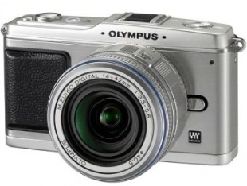
10 | Imprimanta Multifunctionala Inkjet HP Deskjet 2050 AIO | 120 | 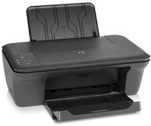
11 | Imprimanta Multifunctionala Konica-Minolta Laser | 300 | 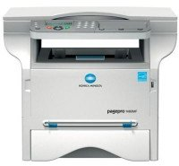
12 | Imprimanta Multifunctionala  Epson WorkForce Pro WP-4545 DTWF | 880 | 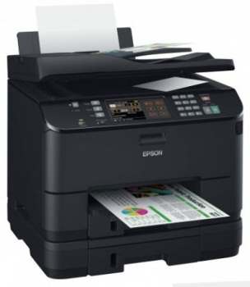
.13 | Router TP-Link TL-WR340G | 40 | 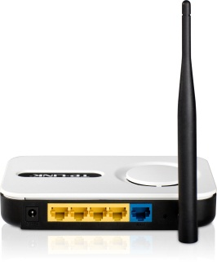
14 | Router TP-Link TL-WR1043ND | 130 | 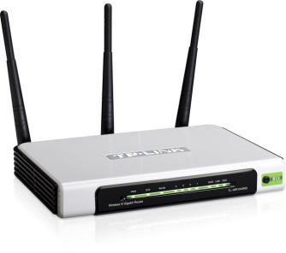
15 | Router Asus RT-N56U | 300 | 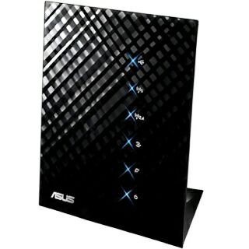
16 | Proiector Aiptek T15 | 320 | 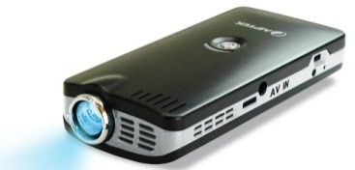
17 | Proiector Sapphire 4E000-00-40R | 800 | 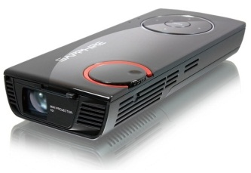
18 | Proiector BenQ MS612ST | 1290 | 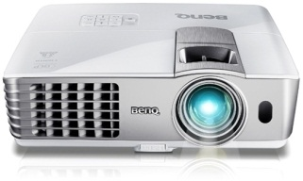
19 | Televizor LCD TECHLINE  Screen Size 22 Inch  Screen Format 16:9  Display Resolution 1366x768 pixels | 520 | 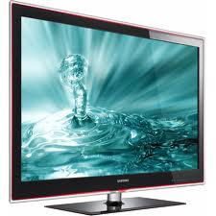
20 | Televizor LCD, Diagonala 32 inch, Rezolutie 1920 x 1080 pixeli, Luminozitate 550 cd/m2, Contrast 60000:1, Aspect ratio 16:9 | 1100 | 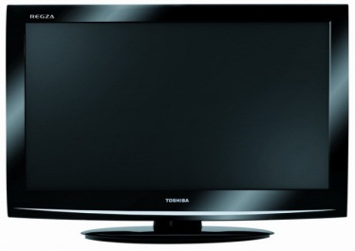
21 | Televizor LCD Diagonala 50 inch, Rezolutie 1366 x 768 pixeli, Luminozitate 1500 cd/m2, Contrast 2000000:1, Aspect ratio 16:9, Timp de raspuns 0.001 milisecunde | 2000 | 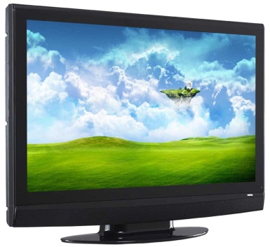
22 | Laptop HP AMD Dual-Core E-300 1.30GHz, 2GB, 320GB, AMD Radeon HD 6310M, Free DOS, Negru | 1000 | 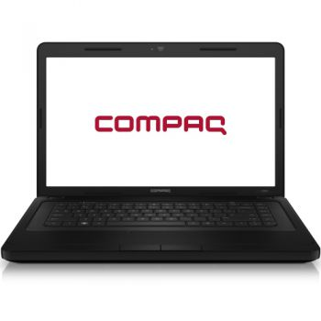
23 | Laptop Acer TM5760-2334G50Mnsk cu procesor Intel® CoreTM i3-2330M 2.20GHz, 4GB, 500GB, Intel® HD Graphics, Linux, Gray | 1700 | 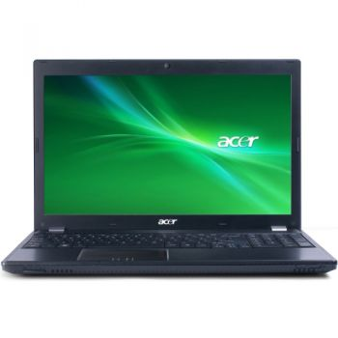
24 | Laptop Samsung NP3V5A-S01RO cu procesor Intel® CoreTM i3-2310M 3.10GHz, 8GB, 500GB, nVidia GeForce GT 520MX 1GB, Microsoft Windows 7 Home Premium | 2400 | 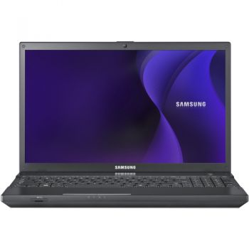
25 | Fax Philips HFC325, cu telefon si copiator, viteza model 9,6Kbps, memorie 15 pag, memorie agenda 50 numere, consumabil rola hartie 30m | 300 | 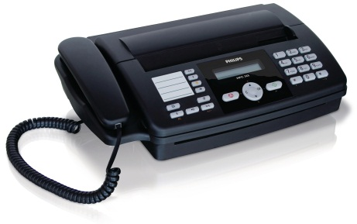
26 | Fax Philips FL61FX Transmisie rapida a documentelor 14,4 kbs Viteza de transmisie 8 secunde/pagina Memorie documente 170 pagini | 800 | 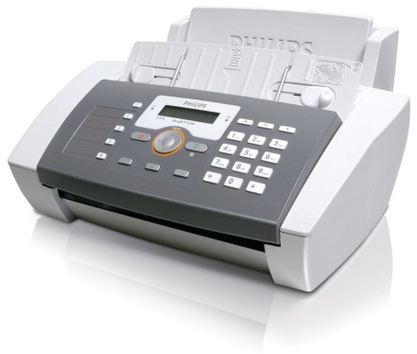
27 | Fax Panasonic UF-4100-YC Fax laser multifunctional cu hartie A4, Panasonic UF-4100-YC, cu operare multi-tasking, transmisie de mare viteza, consum redus de energie | 1600 | 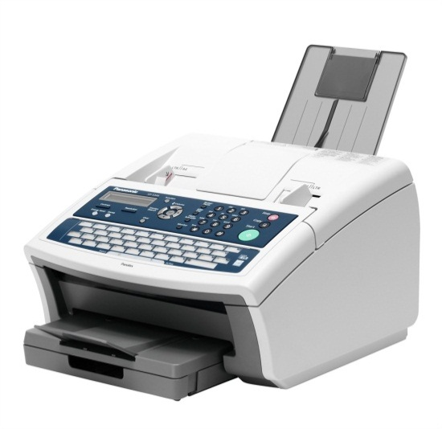
28 | HP INK 901XL J4524 BLK 700PG  Capacitate(pagini): 500 | 30 | 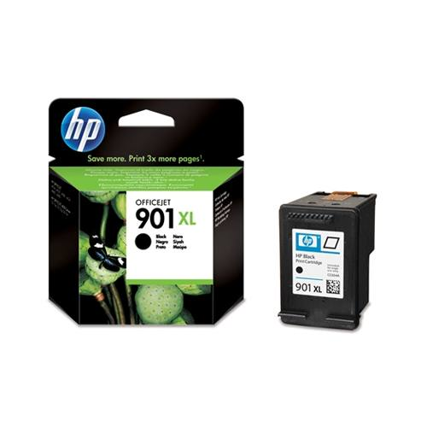
29 | HP 901 Tri-colour Officejet Ink Cartridge  Capacitate(pagini): 500 | 40 | 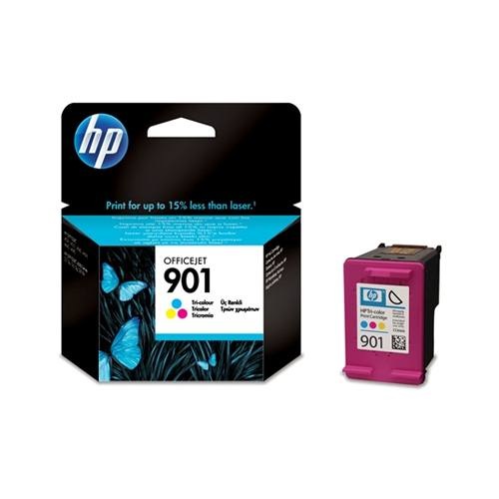
30 | Cartus Laser compatibil Konica Minolta  Capacitate(pagini): 3000 | 80 | 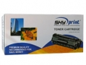
31 | Cartuse resetabile epson  Cartuse goale autoresetabile epson.cel mai economic mod de a printa | 80 | 